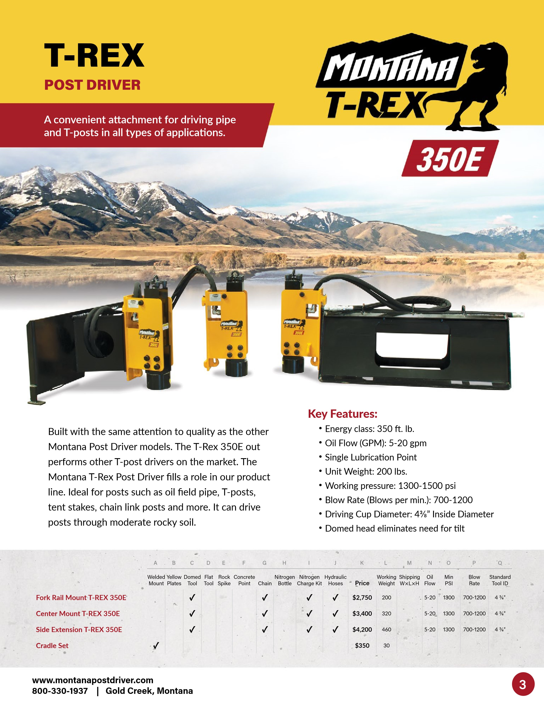

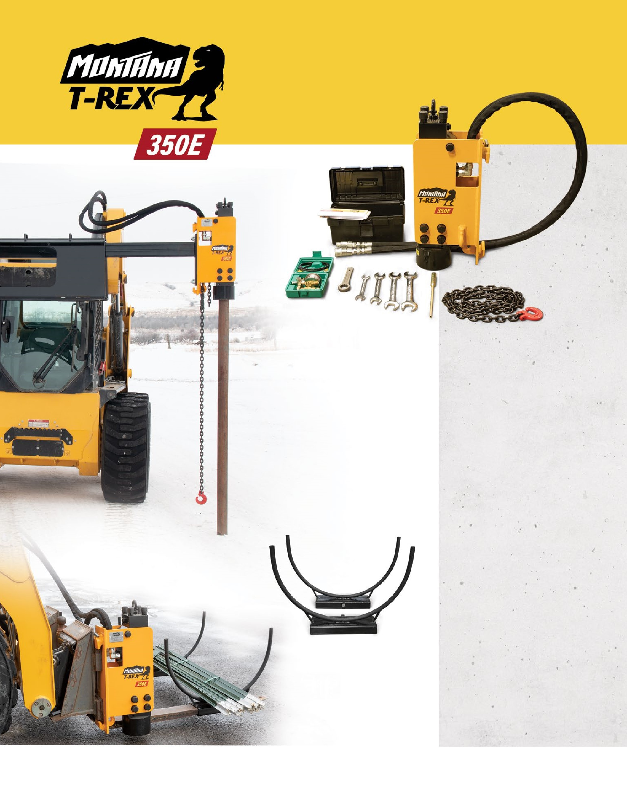

MPD-Trex-v2.1-12-2022

**www.montanapostdriver.com**

**| Gold Creek, Montana**

**800-330-1937**

**T Post Cradle/Saddle**

**(**

**2)**

**set of**

**Every T-Rex 350E**

**Side Extension**

**T-REX 350E**

**DRIVE**

**PIPE &**

**T-POSTS**

**in many**

**applications**

**.**

**Includes:**

•

Hydraulic Hoses with

  flat face couplers

•

Nitrogen Charge Kit

•

Chain

**Does not include:**

•

Nitrogen bottle

16

3

/4”

18

1

/2”

***The ORIGINAL Hydraulic Hammer Post Driver***