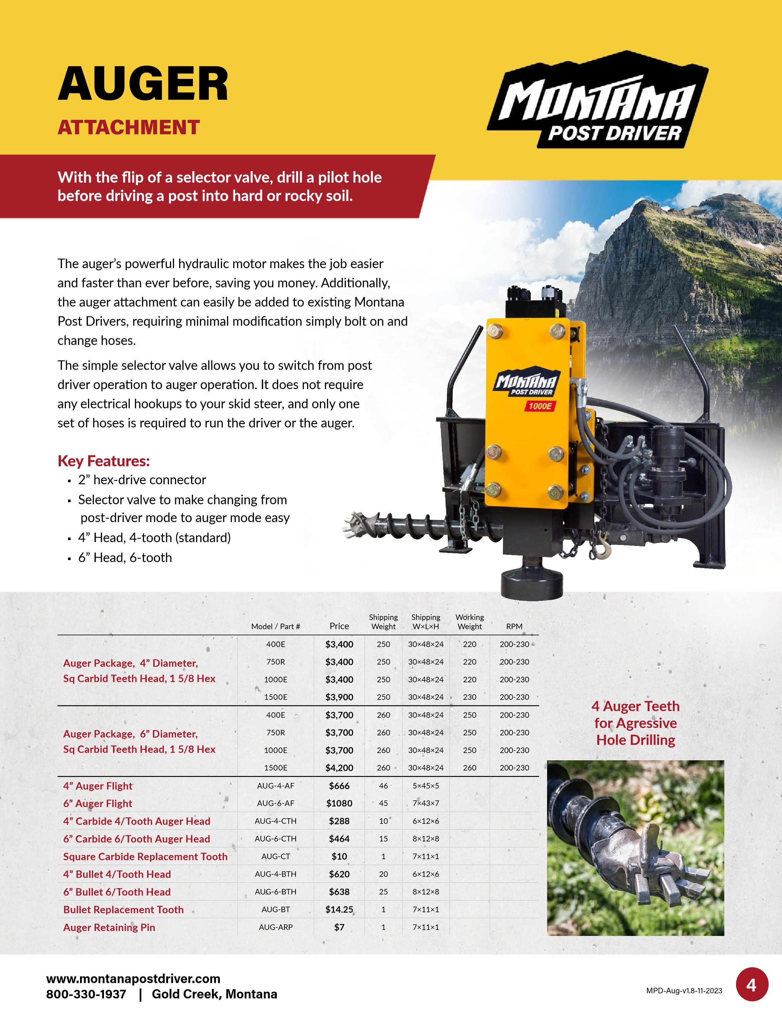

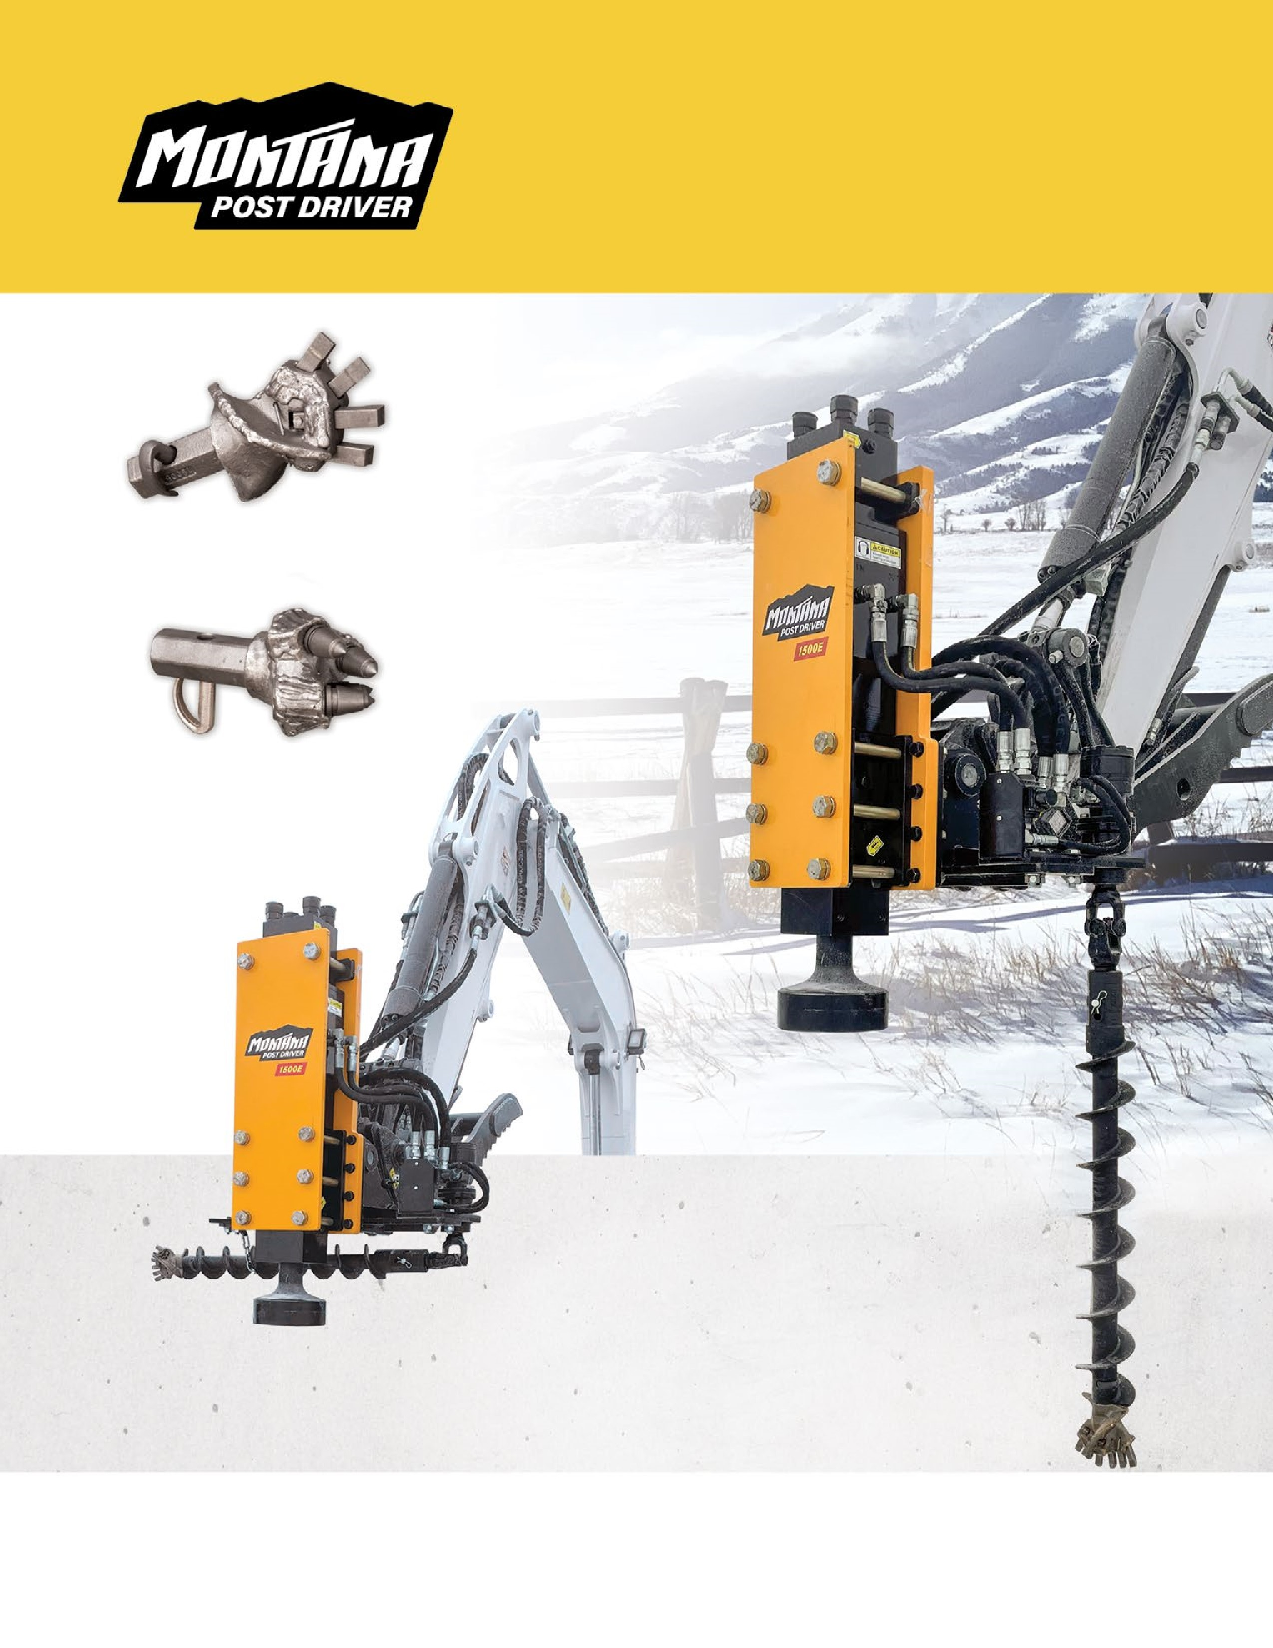

**www.montanapostdriver.com**

**800-330-1937**

**| Gold Creek, Montana**

**Auger attachment for**

**excavator post driver**

***The ORIGINAL Hydraulic Hammer Post Driver***

**4**

**” Carbide 4/Tooth Auger Head**

**4**

**” Bullet 4/Tooth Head**